A New Paltz Worker by Kendall Lucchesi
I pull into the parking lot uncharacteristically late; reading 9:55am on my dashboard, I stress about what I have yet to do. Although the parking lot is filled with the cars of my coworkers, I find my spot empty, waiting in anticipation for my car to give it a purpose. I ran up the stairs, hair amess, server apron slung over my shoulder, calculating the amount of time remaining for me to complete my duties. I’m greeted by smiling faces, hugs, and worry. All my tasks have been completed, nothing for me to do. “A Cornerstone of New Paltz.” Family.
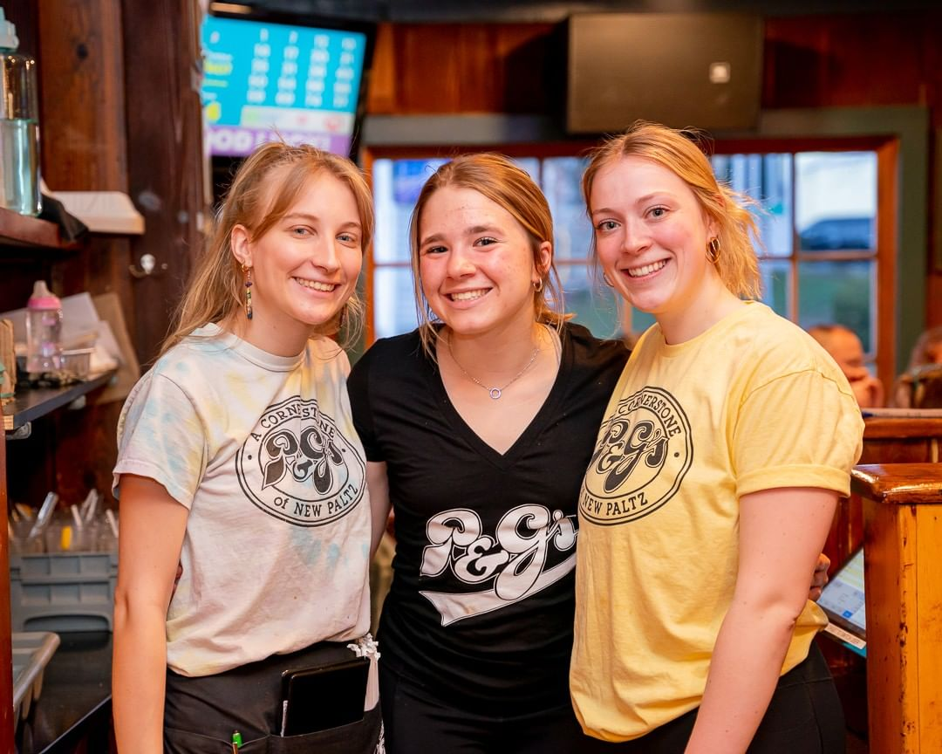
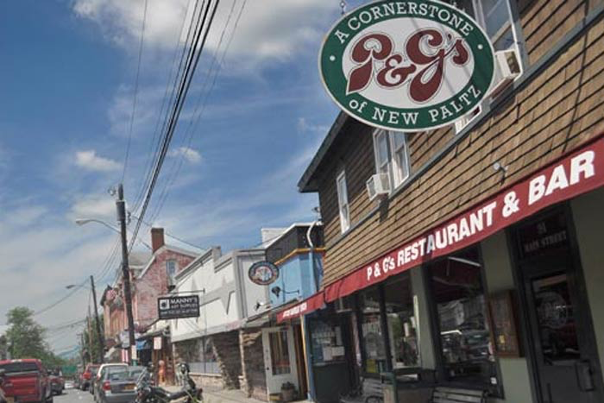

A New Paltz Family by Kendall Lucchesi
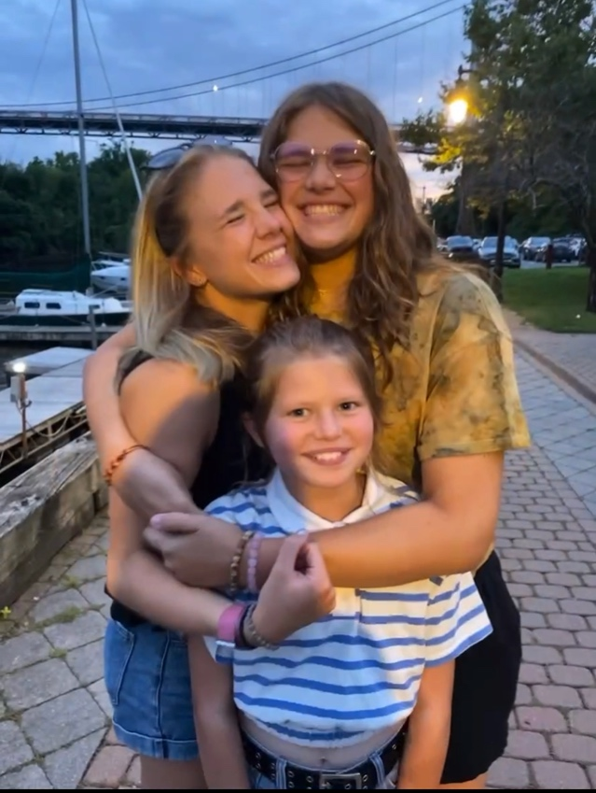
I walk through the door I have walked through at least one thousand times in my life. Frustration regarding school, work, and sports bubbling over like molten lava, I am greeted by a pile of dirty dishes, my sisters’ job that week. Feeling on the verge of eruption, I think of them. How were their days? How was their workload? What were they feeling? I wash the dishes. My parents came home and praised my sisters’ work. There was a knock on my door that night. Instead of a question from my parents, a hug from both of my sisters.

A New Paltz Friend by Kendall Lucchesi
Tissues. Tears. Ice cream. Dumped three days before prom. My room, in its new perpetual state of darkness, was the only place I wanted to be. I acknowledge the glowing, tormenting, “10:00pm” as a sign to try to sleep. As I try to escape my reality, a knock interrupts my thoughts. I open the door, an unfamiliar action, and I am greeted with light. My friends, the same ones I had isolated myself from for the past view days, are in my doorway parading flowers and candy. A proposal the night before prom, a reason to get out of bed. 